Information Security and Assurance Permissions and File Sharing Lab

For each task with an asterisk (\*) add a screenshot (full screen, do not crop)

If you have not already done so, go back and perform the user tasks from the previous lab to make sure the users are present on your systems and have passwords.

Open HyperV in your VM

Start the DC1 system and wait a few minutes till the system is fully booted

Start and connect to the MS1 system and wait a few minutes (if it’s already running, reboot it)

Shutdown the PC1 and LX1 systems



Go to the Settings of the LX1 machine and make sure it’s on the vLocal network and click OK

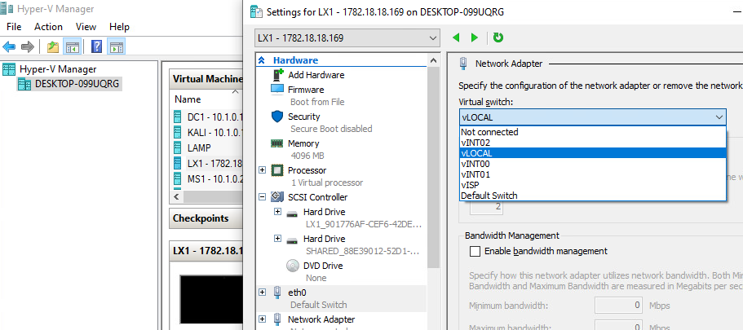

Start and connect to the PC1 and LX1 systems

Log into the PC1 machine as PC1\Admin

Log into the LX1 machine as centos

\*On the LX1 system open a terminal and type ip a to get the system’s ip address and write it down here:

 

If you get anything other than an address that starts with 10. let the professor know.

\*Now run the following commands:

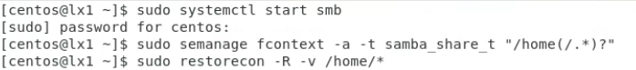

After this command you will see a bunch of output about resetting things.

\*Then type these commands.



What did the systemctl, semanage, and firewall-cmd commands do on the system?

Go to your PC1 machine through HyperV

Open PowerShell and type ipconfig to get the IP address of the system. Write it down here.

If you get anything other than an address that starts with 10. let the professor know.

Access the Linux fileshare (File Explorer then type \\ and the ip address of the Linux system you wrote down above (i.e \\150.1.2.3 then press <enter> or the right arrow key on the right of the address bar)

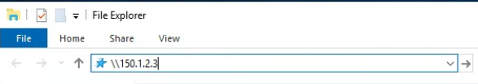

\*Authenticate with the user LX1\mike and navigate to his Desktop directory. (it may take a few moments for the authentication to pop up)

Where (which system and path) is the file here located?

On the PC1 machine, log off then log back on again as PC1\Admin (this will clear Mike’s cached credentials to the Linux machine)

\*Access the Linux fileshare again using LX1\jolene to authenticate this time

What does this tell you about what directories are being shared by the Linux system by default after we turned on Samba?

What do you think are the share permissions for the Linux shared directories? How do you know?

\*On the PC1 system share the C:\Users directory (Properties-Sharing-Advanced Sharing-Share this Folder)

On the Linux system access the PC1 shared directory by double clicking the Home folder on the Desktop, selecting + Other Locations and typing at the bottom smb:// then the ip address of the PC1 system (i.e. smb://124.6.2.12) then click the Connect button

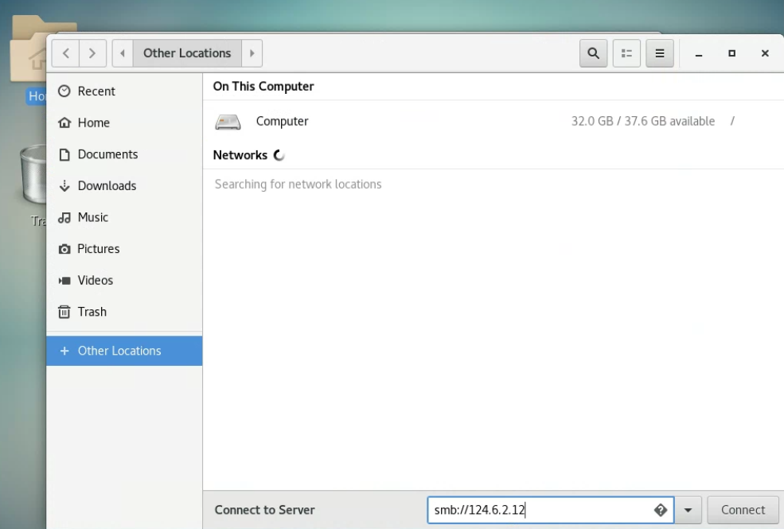

Authenticate using mike’s account (keep the Domain setting the same, just type the username and password).

\*What directory (which system and path) are you seeing here?

Try to go into Jolene’s directory.

Why were you not allowed to do so?

Go into Mike’s directory and try to create a file.

Why were you not able to create a file here?

\*On the PC1 machine what is the minimum password length set to?

\*Are any audit policies set on the system?

What would these audit policies provide for the system administrator or cybersecurity professional if enabled? How are they important?